Krutika Ramwani (Student ID: 49379605)

Junda Liu (Student ID: 88015821)

Lydia Zheng (Student ID: 22738009)

Isha Mahendra (Student ID: 48923437)

BAMS 508 HOMEWORK 2

BAMS 508 HW 2

**School bussing problem revisited**

1. The values may not be integer because some constraints make this problem not satisfy the requirement to have Integer Solutions Property. In a MCNF model, all supply and demand should be integer if we want to obtain the integer solutions. However, in this problem the constraints that specifies “each grade must constitute between 30 and 36 percent of each school's population” will make supply be in a range. So the supply can take any number between the range and thus can be non-integer values. Therefore the solutions for this problem may not be integer and we should set the variables type into integer in order to ensure the solutions are integer values.

b. Given all other variables and constraints remain unchanged, we should add the following variables and constraints:

1. **Add new variables:**

We have added a new set of variables $b_{i,j}$ to represent the number of buses needed for each assignment. $b_{i,j}$ are integer variables, which represent the number of buses needed to assign students from area i to school j.

1. **Add new constraints:**

We should also add the capacity constraints for the buses.

**New constraints 1:** The total bus capacity is the total number of students the bus can carry from area i to school j.

$$60∗b_{i,j}>= x_{i,j}$$

**New constraints 2:** We do not overuse buses.

$$60∗(b_{i,j}−1)< x_{i,j}$$

**New constraints 3:** Students in some area i do not require buses to go to school j

$$b_{i,j}= 0 for some i,j pairs$$

c. The new solution after adding the above constraints is as follows:

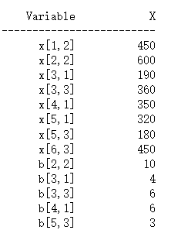

The optimal bussing cost is $1,728,000

x[i,j] here in the above results means the number of students we should assign from area i to school j.

We should:

* Assign 450 students from area 1 to school 2
* Assign 600 students from area 2 to school 2
* Assign 190 students from area 3 to school 1
* Assign 360 students from area 3 to school 3
* Assign 350 students from area 4 to school 1
* Assign 320 students from area 5 to school 1
* Assign 180 students from area 5 to school 3
* Assign 450 students from area 6 to school 3

b[i,j] here in the above results represents the number of buses needed to assign students from area i to school j.

We should:

* Add 10 buses to transfer students from area 2 to school 2
* Add 4 buses to transfer students from area 3 to school 1
* Add 6 buses to transfer students from area 3 to school 3
* Add 6 buses to transfer students from area 4 to school 1
* Add 3 buses to transfer students from area 5 to school 3

d. We could solve the problem in part (d) by adding the following variables and constraints from part (b):

1. **Add new variables:**

$$y_{i,j}=0 or 1$$

$y_{i,j}$ is a set of binary variables, which only take value 0 or 1, it represents whether to assign students from area i to school j.

$y_{i,j}=0$ means that student in area i is not assigned to school j.

$y_{i,j}=1$ means that student in area i is assigned to school j.

1. **Add new constraints:**

We should also add 2 new constraints without changing other constraints:

**Constraint1**: to make the assignment of students from area i to school j equals to the supply of the students in area i

$$\sum_{j}{x_{i,j}∗y_{i,j}}={Area}_{i} for i =1,2,3,4,5,6$$

**Constraint2**: to enable each area to be assigned to just one school

$$\sum_{j}{y_{i,j}=1}for i = 1,2,3,4,5,6$$

1. **Alter some of the constraints:**

As what we did for Optimal Decision I HW 1 part(d), we should also alter the following grade percentage constraints to make our model feasible:

* Each grade must constitute less than or equal to 36 percent of each school’s population.
* Each grade must constitute more than or equal to 30 percent of each school’s population.

e. What is the new solution? (building off of the formulation/solution from parts b and c).

The new solution is as follows:

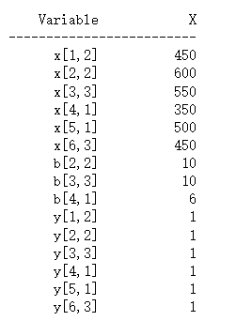

Explanation:

(1) The optimal bussing cost is $1,460,000

(2) For variable y[i,j], We should:

* assign student in area 1 to school 2
* assign student in area 2 to school 2
* assign student in area 3 to school 3
* assign student in area 4 to school 1
* assign student in area 5 to school 1
* assign student in area 6 to school 3

(3) For variable b[i,j]:

* 10 buses are needed to transfer students from area 2 to school 2
* 10 buses are needed to transfer students from area 3 to school 3
* 6 buses are needed to transfer students from area 4 to school 1

**Burrito Optimization Game, revisited**

1. function, f(d) for providing a good fit for predicting the fraction of total demand that will travel a distance of d for a burrito:

$$α_{ij}=\left\{\begin{aligned}0 if d≥300 \\ −0.005d+1.5102 \\ 1 if d≤100\end{aligned}\right. if 100<d<300$$

In the above formula $d$ is the explanatory variable and $α_{ij}$ is the response variable, $d$ represents the distance between i and j. **(We used the data files on canvas for this problem and the downloaded date files for the remaining questions)**

First, we plot the relationship between $α_{ij}$ and $d$ in one diagram as follows:

From the diagram we can figure out there is a piecewise linear relationship between $α_{ij}$ and $d$. The break points are (100,1) and (300,0), therefore we further break the relationship into 3 parts:

(1)When 100< $d$ <300:

We add regression function to the diagram. The R-square of the model is 0.9949 which signifies a very high goodness of fit, therefore we can use this function to predict the fraction total demand.

(2)When $d≥$ 300:

We find that when $d≥300$, the $α_{ij}$ always equal to 0. Therefore we will assume that the customer will not have any demand if the distance between demand and location equals or exceeds 300.

(3)When $d≤$ 100:

We find that when $d≤100$, the $α_{ij}$ always equal to 1. Therefore we will assume that the demand of the customer will not be affected by distance if the distance between demand and location equals or less than 100.

b. We used the downloaded data files for this problem and we have uploaded the data we used for this question.

The output from Gurobi is as follows:

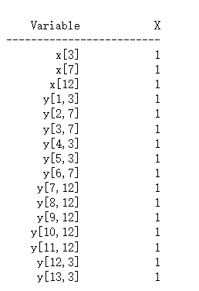

The optimal value of the model is $625, which is consistent with the optimal solution shown by Burrito website:

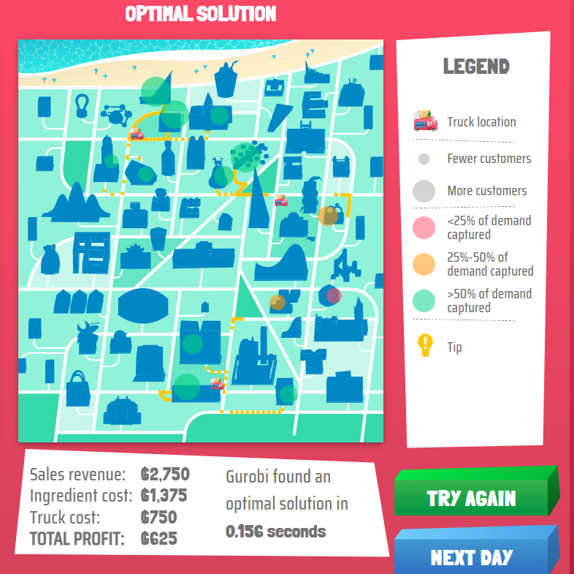

**Explanation:**

i and j here represents the index of the customers and truck location, it does not represent the exact name of the customers and truck locations. We printed the exact names of the demands and truck location to make the following explanation, the details can be found in Jupyter Notebook.

**For variable x[i,j]:**

* we should put truck at location truck8
* we should put truck at location truck18
* we should put truck at location truck42

**For variable y[i,j]:**

* customers in demand2 should go to truck8
* customers in demand11 should go to truck18
* customers in demand13 should go to truck18
* customers in demand15 should go to truck8
* customers in demand16 should go to truck8
* customers in demand24 should go to truck18
* customers in demand34 should go to truck42
* customers in demand35 should go to truck42
* customers in demand40 should go to truck42
* customers in demand41 should go to truck42
* customers in demand49 should go to truck42
* customers in demand52 should go to truck8
* customers in demand53 should go to truck8

c. We used the downloaded data files for this problem and we have uploaded the data we used for this question.

In this question we made the following changes:

(1) We have created new sets of variables $d_{i,j}$ which represents the number of demands in demand i is satisfied by truck.

(2) We have transformed $x_{j}$ from binary to integer, in question (c) here, $x_{j}$ represents the number of trucks put in location j.

Formulation for part c is as follows:

**Variables:**

$d_{i,j}$ number of demand flow from customer i to location j.

$x_{j}$ number of cars put in location j.

**Objective function：**

Maximize:

$$\sum_{i,j}{5∗d_{i,j}−\sum_{j}{{150∗x}_{j}}}$$

**Constraints:**

**Constraint 1: truck number constraint**

$$\sum_{j}{x_{j}≤16}$$

The total number of the trucks should be equal or less than 16.

**Constraint 2: truck capacity constraints**

$$\sum_{i}{d_{i,j}≤30∗}x_{j}$$

The total capacity of trucks in location j should be able to satisfy the demand flowing to that location.

**Constraint 3: Total demand constraint**

$$\sum_{j}{d_{i,j}≤{demand}_{i}}$$

The total demand for i should be equal to or less than the demand of that area.

${demand}_{i}$ here represents the total demand for customer i.

**Constraint 4: scaled demand constraints**

$$d_{i,j}≤{scaled_demand}_{i,j}$$

The demand from customer i to location j should equal to or less than the scaled_demand from i to j. ${scaled_demand}_{i,j}$ here represents the scaled demand from customer i to truck location j.

And the results is shown as follows:

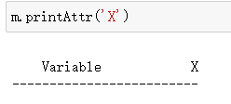

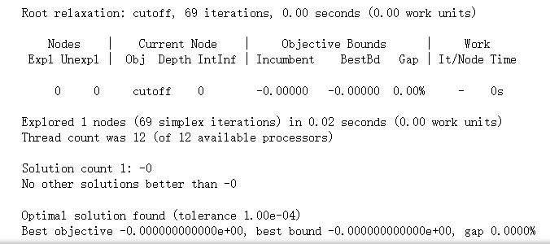

The algorithm told us that the optimal solution is not to put any car in any locations. It just means “do nothing” is the optimal solution.

**Managerial discussion and explanation:**

If we look at the profit and cost parameter, we can find that, the truck earns $5(10-5=5) for each person, and the maximum capacity for each truck is 30, which means each truck can earn a maximum profit of $150(5*30=150) at its full capacity.

But it costs us $250 to put one truck, this means maximum profit for each car is -$100(150-250=-100), that means if we choose to operate, we will incur loss, therefore the optimal solution is “do nothing”. But in part b, we do not have to consider the truck’s capacity and assume the truck will satisfy all the demand of the customer coming to it, that is the reason why these two questions have different solutions.

As each truck is going to suffer a loss, we suggest the management could try to cut down the followings:

* Cut the variable cost and fixed cost.
* Substitute the current products with products that earn higher gross margins
* Try to find trucks with higher capacity and equivalent profit margin.